COMPUTING MODULE: CARM 601

PASSWORD CHECKER
Andy Cripps

Solution Design
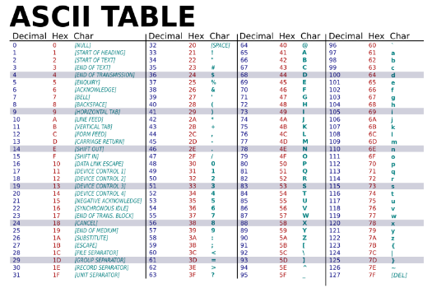
In order to approach this task, I could use strings with the characters or lists in order to check if the characters are in those objects. I will use the function ord() to check if the ASCII value of the character is within the range of the capitals and lowercase etc and then use this to create my selection statements. I will have a main loop that is used to test whether the password is valid and meets all the criteria and then sub tests for each of the criteria when all of these are true it will exit this program.

Modular Design

Flowcharts subprograms
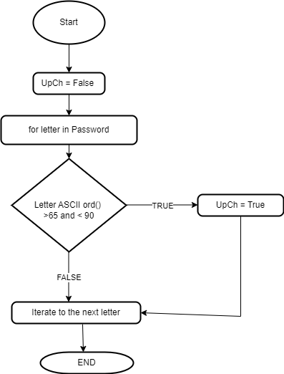
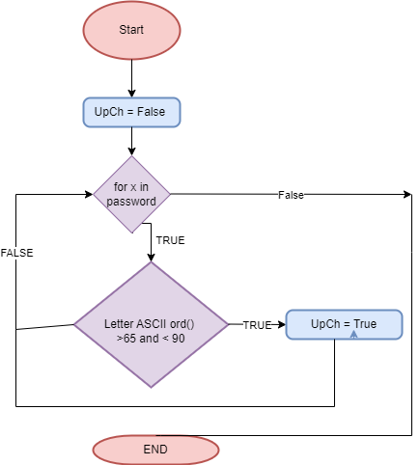
The uppercase, lowercase and special characters will all have a variable that will be to check if the password is valid. By iterating through the password with a for loop and comparing each with an ASCII value 65 to 90 for capitals,

# Uppercase Letter check
UcValid = False

For char in pw: # iterate
If ord(char) > 64 and ord(char) < 98:
UcValid = True
Else
ucValid = False

FUNCTION Uppercheck (pw)
Upper = False
FOR letter in pw
IF ascii (letter) > 64 OR ascii Letter < 90
Upper = true
END IF
END FOR
Return upper
END FUNCTION

Testing and Development

Test Number | Description of test | Test Data | Expected outcome | Actual Outcome
1 | Uppercase subprogram check | Valid = AAAAAAA  Invalid = aaaaaaa  Type = 123432134  Extreme = -1123 | Asked to re-enter password if invalid and not containing an Uppercase character. | All data produced same output of an empty return. No reinputting of the password.  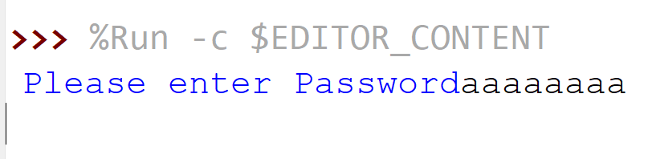
2 | Logic test after moving the input inside the main loop  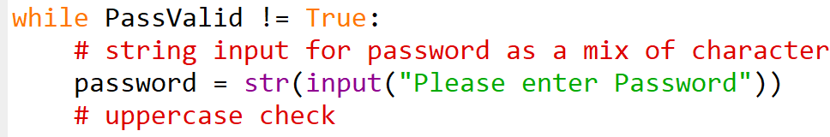 | Valid = AAAAAAA  Invalid = aaaaaaa  Type = 123432134  Extreme = -1123 | Asked to re-enter password if invalid and not containing an Uppercase character. | 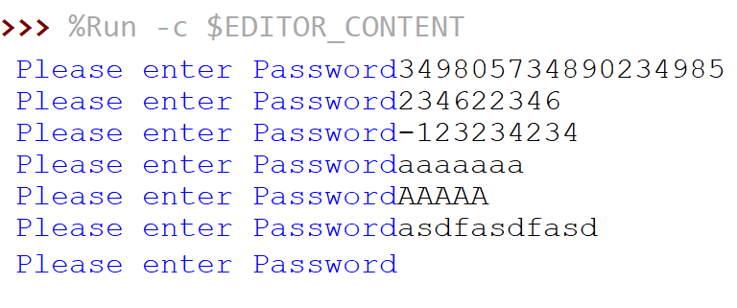
3 | Testing output for the uppercase subprogram to ensure it checks if the characters are valid. Only checking uppercase for now.  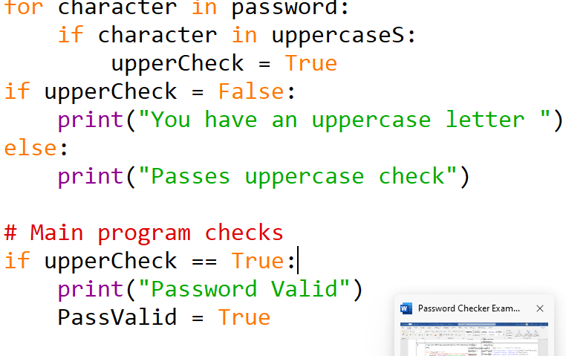 | Valid = AAAAAAA  Invalid = aaaaaaa  Type = 123432134  Extreme = -1123 | Output of passes uppercase check .  Output of Valid password | Ouput needs work for user when incorrect. Displays the wrong message.  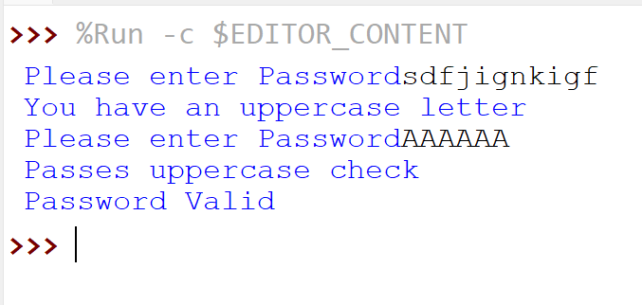
1 | 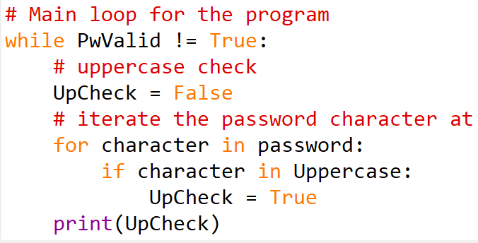  Check inputs for uppercase characters sub program . | Valid = AAAAAA  Invalid = aaaaaaa  Erroneous = 2563465234 | True for Valid  False for Invalid  Return to Input | 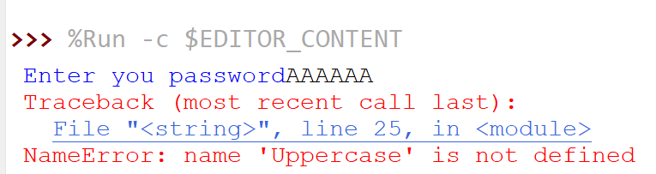  Check variable names  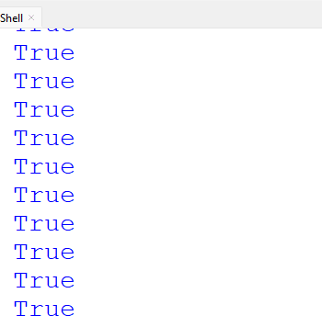  Creates infinite loop
1.1 | 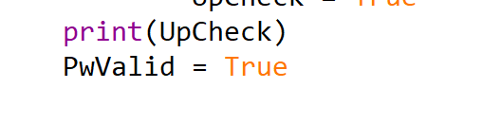  Break the loop after the check to show whether the vaild for uppercase has worked. | Valid = AAAAAA  Invalid = aaaaaaa  Erroneous = 2563465234 | True for Valid  False for Invalid  Return to Input | 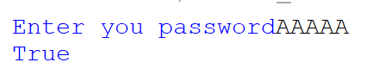  Works with Valid data
 | Checking sub program for uppercase letters  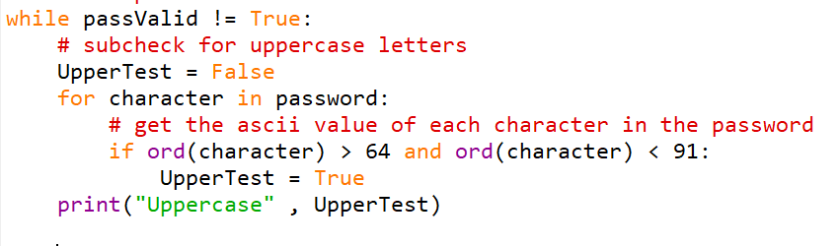 | Valid = AAAA  Invalid = aasdasd  Bound = sdiaisdbf (long string)  Erroneous =  -12  Blank = ‘’ | Uppercase output should be true for valid data.  False for non. Re enter the password. | Creates infinite loop as input is outside of the main loop  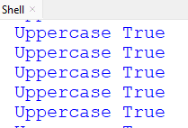
1.1 | Move input inside the main loop and then test the inputs.  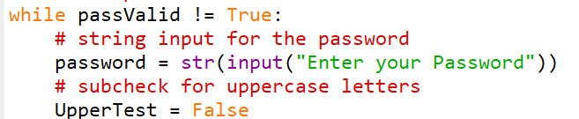 | Valid = AAAA  Invalid = aasdasd  Bound = sdiaisdbf (long string)  Erroneous =  -12  Blank = ‘’ | Uppercase output should be true for valid data.  False for non. Re enter the password. | 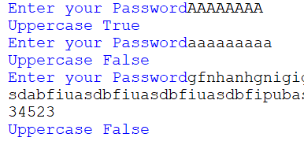  Passes test to check if Uppercase or not with Boolean true or false.

